TYPE CASTING
FROM FLOAT TO INTEGER
PROGRAM:

#include <stdio.h>
int main()
{
float a = 10.75;
int b ;
b= (int)a;
printf("INTEGER VALUE=%d\n", a);
printf("FLAOT VALUE=%.2f\n",b);
return 0;
}
OUTPUT:
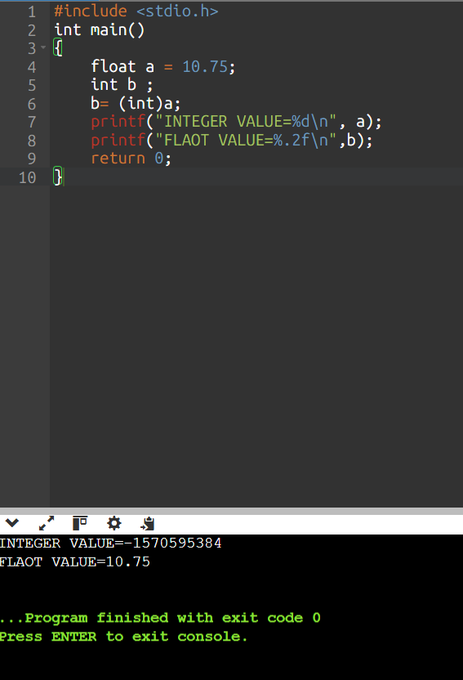
FROM INTEGER TO FLOAT
PROGRAM:

#include <stdio.h>
int main()
{
int a = 10;
float b ;
b= (float)a;
printf("INTEGER VALUE=%d\n", a);
printf("FLAOT VALUE=%.2f\n",b);
return 0;
}

OUTPUT:
